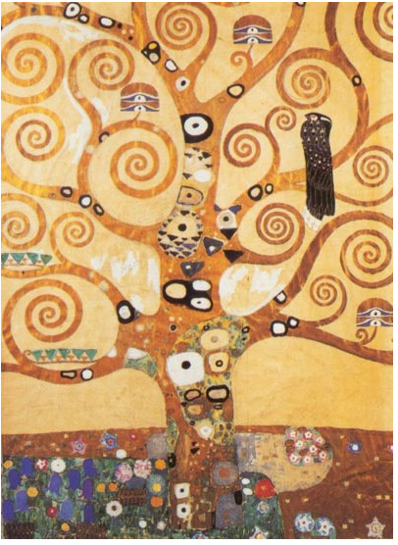**Tree of Life**

**Gustav Klimt**