Task for Term 3 – POPULATE OR PERISH- Immigration after the 2nd World War

Find an image of immigration to Australia after WW 2.
Copy and paste in onto a word document.
Examine the image very carefully.
Explain what you think the image (a primary -historical resource) is telling you (3 -4 sentences).

Example (for the above task)

Image from the WA Museum
Mrs Lydia Drescheris and children travelling from Lithuanua arriving in Perth after WW 2
(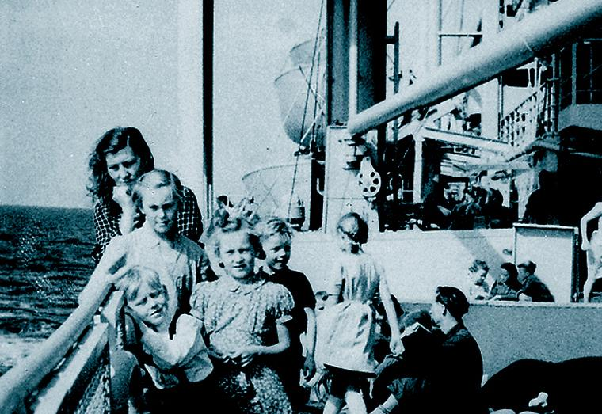
The image shows a mother with 4 young children travelling by ship from Lithuania. The children seem to be dressed in light clothing indicating that it was probably summer when they arrived in Australia. The mother looks pensive or may be worried about the future but the children look more relaxed and happy. With no adult male (in the photo), it may be that the father may have arrived in Australia before the family. It is also a possibility that the father may have died in the war. The ship appears to be carrying other families as well.

