

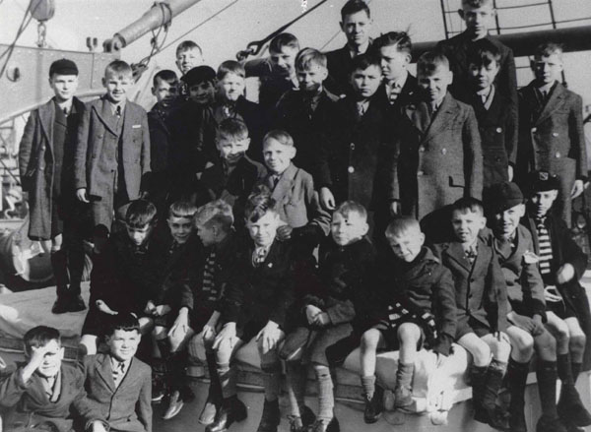









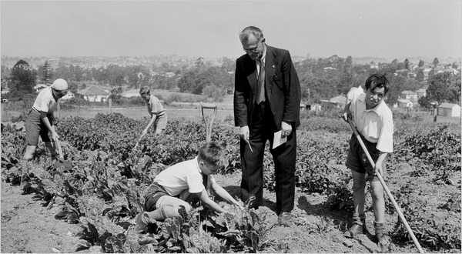



[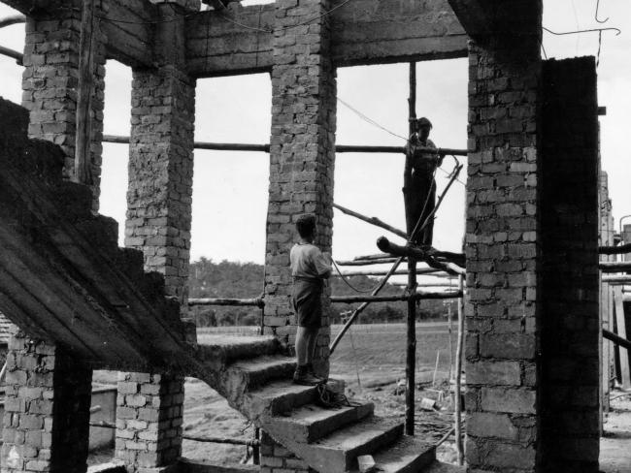](http://www.google.com.au/url?sa=i&rct=j&q=&esrc=s&source=images&cd=&ved=0ahUKEwjD08P30sfVAhWDGZQKHfPjD8AQjRwIBw&url=http%3A%2F%2Fwww.news.com.au%2Fnational%2Fformer-child-migrants-sent-to-australia-to-testify-at-uk-inquiry-into-sexual-abuse%2Fnews-story%2F7caff6e1077ec3af35a95ac178261520&psig=AFQjCNEqsr2GQOkAaUfx3RHtrb_pCwKSyw&ust=1502281807752591)

