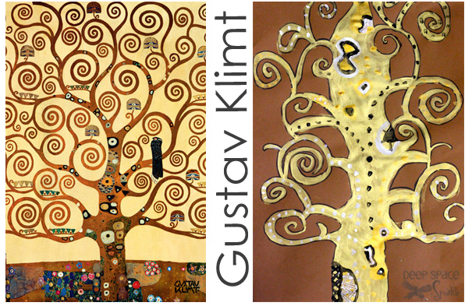

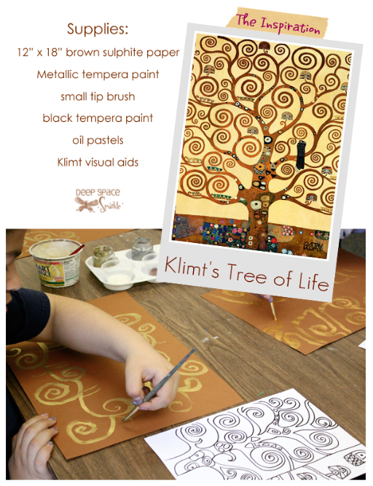
Start by painting the trunk. Paint the trunk in fluid motions by drawing the sides swaying as opposed to drawing straight lines. Extend branches from the centre and use swirls at the tips of each branch

Use white paint and oil pastels to add patterns or designs and paint over the gold.

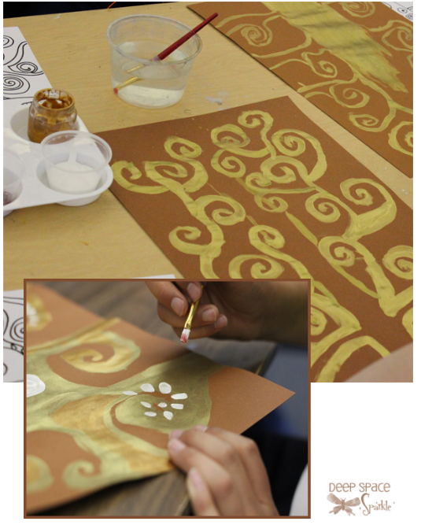

The final step is to use black paint to outline all of the tree branches.

