**Oscar Romeo**

(1917 – 1980)

Archbishop of El Salvador’s capital San Salvador, was a voice for the poor and a beacon of truth when thousands of Salvadorians were being killed and kidnapped by the military. Romero spoke of hope and justice in a time of darkness and stood in solidarity with the poor and marginalized people of El Salvador. Like many leaders who defend the truth, Romero was assassinated in 1980 whilst celebrating mass.

What does the leader / person CARE about?

What does the leader / person BELIEVE is important?

What does the leader / person THINK is important?

What makes you say that?

Write a one sentence summary eg

I think (leader’s name) values from VALUES worksheet) because they (action/s they do).

Include a picture if possible.

EXAMPLE (Your work should look like this.)

Romero CARED about people who were struggling to help themselves.

Romero BELIEVED in treating everyone fairly (with justice).

Romero THOUGHT it was important to stand up for what you believe in, be responsible and contribute to the world.

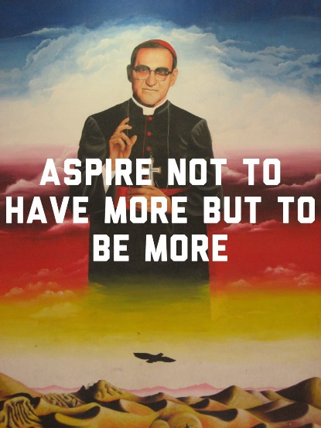Romero VALUED people being treated equally and fairly because (ACTION) he spoke out for the poor and even though he knew it could (and did) mean he would be killed himself for doing so.

Oscar Romero

(1917 – 1980)